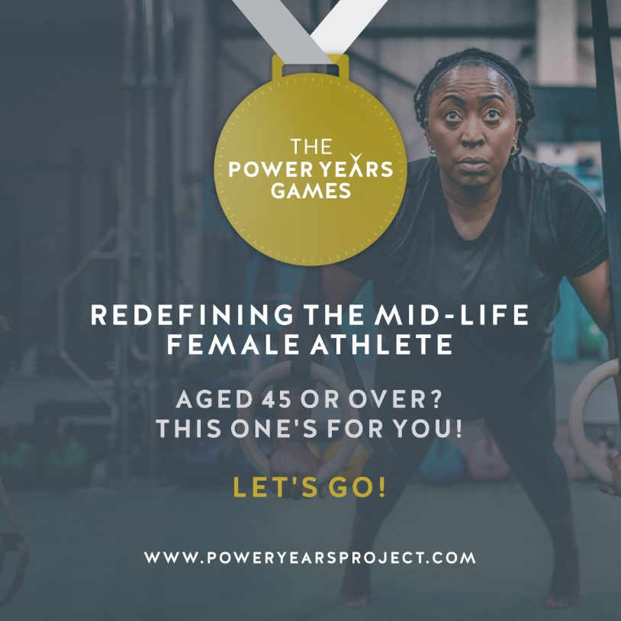

The Rules and FAQ’S

Hey Girl…………
- YOU MUST BE AGED 45 OR OLDER TO TAKE PART IN THIS CHALLENGE – NO EXCEPTIONS! You cannot enter the Participants Group or log your scores on the Leader Board if you do not meet the age criteria. NO EXCEPTIONS!
- You can join in at any point in the contest but the earlier you join, the more time you have to condition yourself for the harder work to come as the Rounds progress.
- The workout for each Round will be posted just before the start date for each Round. The workout video demonstration for each Round can be found in the POWER YEARS GAMES PARTICIPANTS FACEBOOK GROUP PAGE
- All of the workouts are ‘for time’ ie., perform the workout as directed and record your total time for completion then log on the LEADER BOARD which is accessible on the website but the password is posted in the Facebook Group.
- When you have completed the workout, simply post your time for the completed workout on the Leaderboard on the Power Years Project ® Website – HERE’S THE LINK!
- Within the start and end date for the Round you may attempt and post as many times for the workout as you want to.
- Perform the exercises EXACTLY AS SHOWN. There will be a video of each workout for absolute clarity. THERE ARE NO SUBSTITUTE EXERCISES.
- The workouts will be progressed each round so probably wise to get in at the beginning to allow your body time to adapt naturally to the increasing demand.
- Once you have entered Round 3, there is a NO REFUND POLICY on your entrance fee of £10 as this contributes to the prize money for the GRAND FINAL WINNER!
- Who will check that you’ve done what you’ve said you’ve done in the time you’ve posted – NOBODY! And that’s not a problem at all because if you fib and post that you’re faster than you actually are and reach the finals with people who have actually told the truth, it’s not going to be fun for you. So you only stand to cheat yourself!
- If you reach the FINAL 10, you MUST be able to attend WOMAN ON FIRE 2019 in Brighton, UK on the weekend of 27/28 April, 2019 for the GRAND FINAL. If you cannot, you’ll forfeit your place and a replacement will be found as we MUST have 10 finalists.
- If you’re outside of the UK and you can’t attend the LIVE GRAND FINAL, you may still enter the challenge and join the community and use it as a ‘personal fitness quest’….it’s all good
- The GRAND FINAL WORKOUT will be posted on Friday 26th April. The final 10 Athletes will go head-to-head at Woman on Fire 2019 observed by official counters and event participants. It’s going to EPIC! And WINNER TAKES ALL!

So, are you ready to claim or reclaim your ‘Athlete Status’?

If YES, follow these 5 Steps To Get Started
Step 1: Go to the Power Years Project® Website, click on the tab for the POWER YEARS GAMES and the Round you’re entering, type in the password for the Leaderboard to access. Add your name Leaderboard HERE.
Step 2: Join the The Power Years Games PARTICIPANTS FB Group alongside all your fellow competitors.
Step 3: Complete the Health Waiver Form – link in FB Group.
Step 4: View the ‘How To Do It’ Video for the Round you are entering and then get going and complete your first workout and log your time on the Leaderboard.
Throughout the timeframe of the Round, you may attempt the workout as many times as you want and post your amended score on the Leaderboard.
Step 4: Share your results and success in the FB Group.
Step 5: Share this GROUNDBREAKING EVENT with any woman you know over the age of 45 who you think would love to take part. Remember you can take-part anywhere in the world even if you can’t make the Grand Final in the UK in late April!

And……..it’s a total WIN WIN, you’ll get fitter, faster and stronger, be in a community of kick-arse women AND stand a chance of winning a lot of money and attending Woman on Fire for FREE . It actually doesn’t get better than this!! XX

Here’s to you reclaiming your ‘Athlete Status’!

Big Love and #powerup,
Jenny Burrell
